**Software Architecture  
M.T.A.**

**Prepared by Vasile George-Iulian  
Trifu Andrei  
Stefan Adrian-Catalin**

1. **Use Cases:**

**-View/Edit Apartment case:**

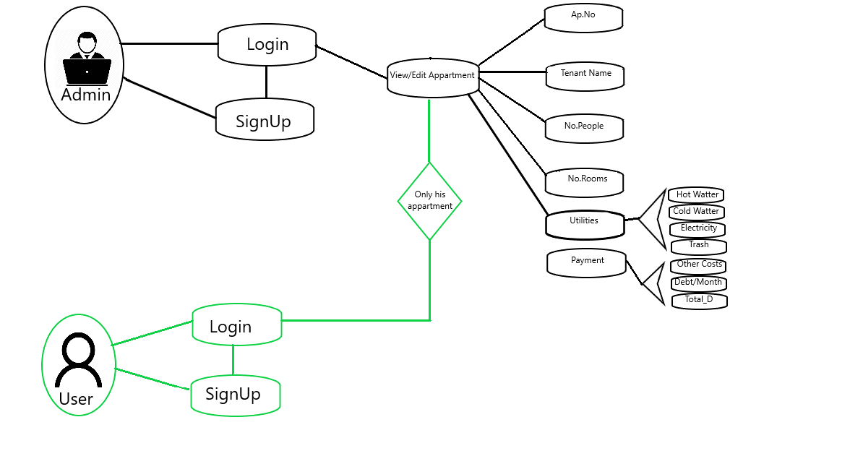

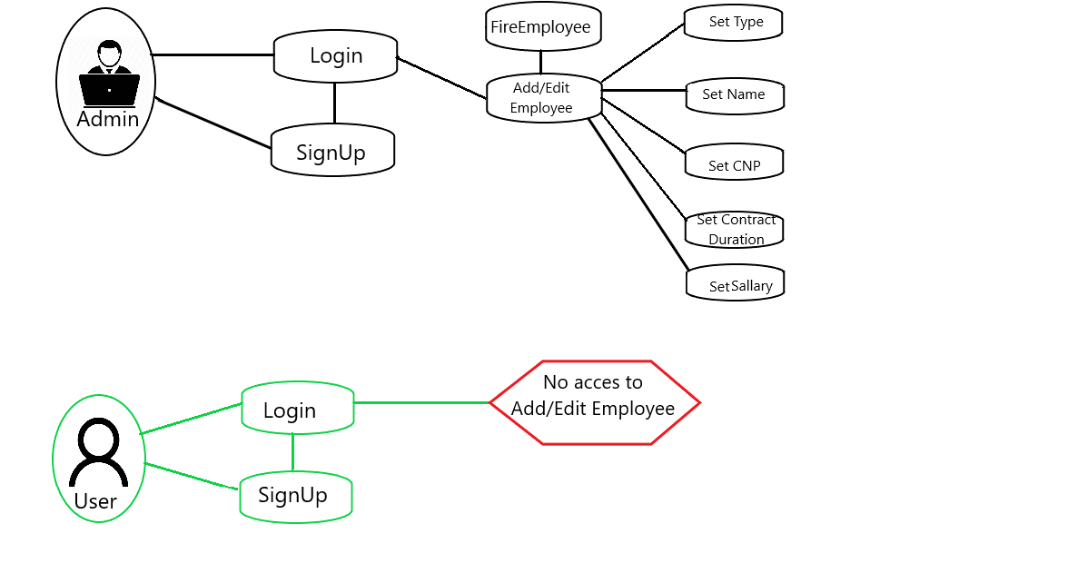**-Add/Edit Employee case:**

**-Register/Edit Contract case:**

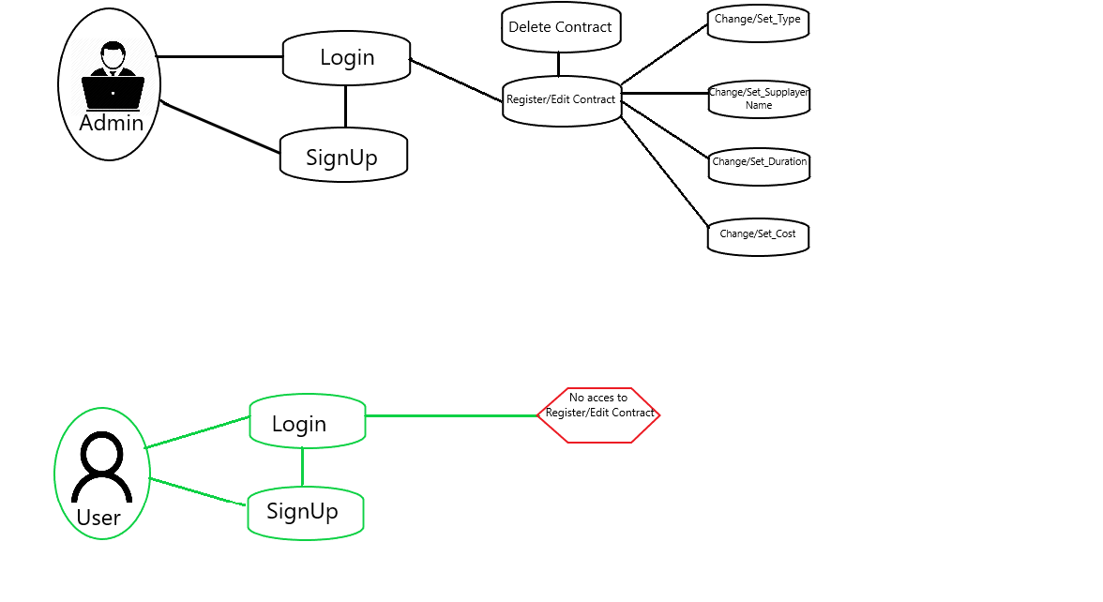

**-View Payment Report case / Create / View/ Answer Pool / Contact M.T.A. cases**

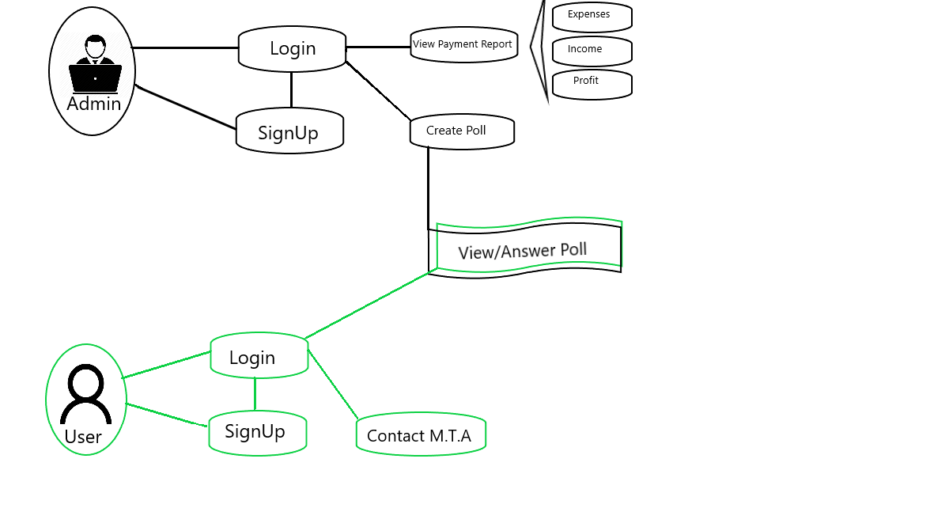

1. 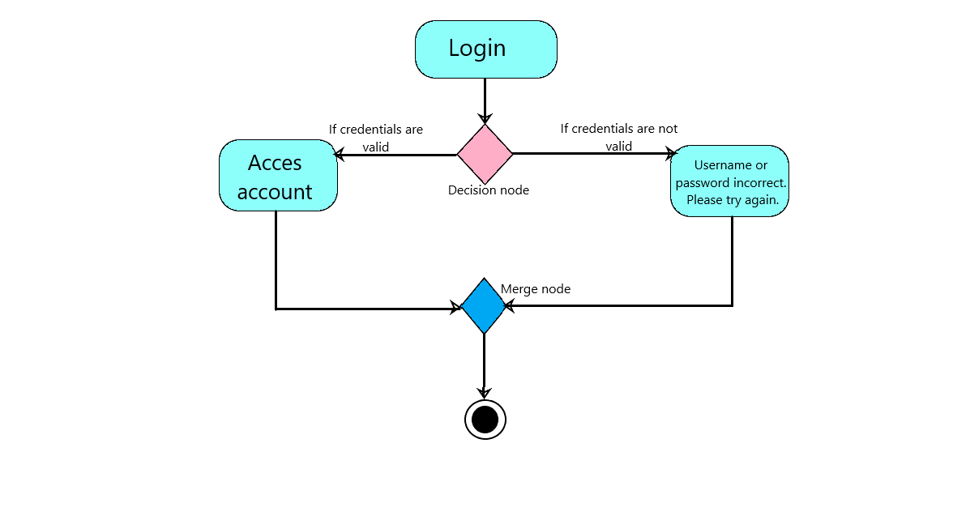**Activity Diagrams:**

Login diagram:

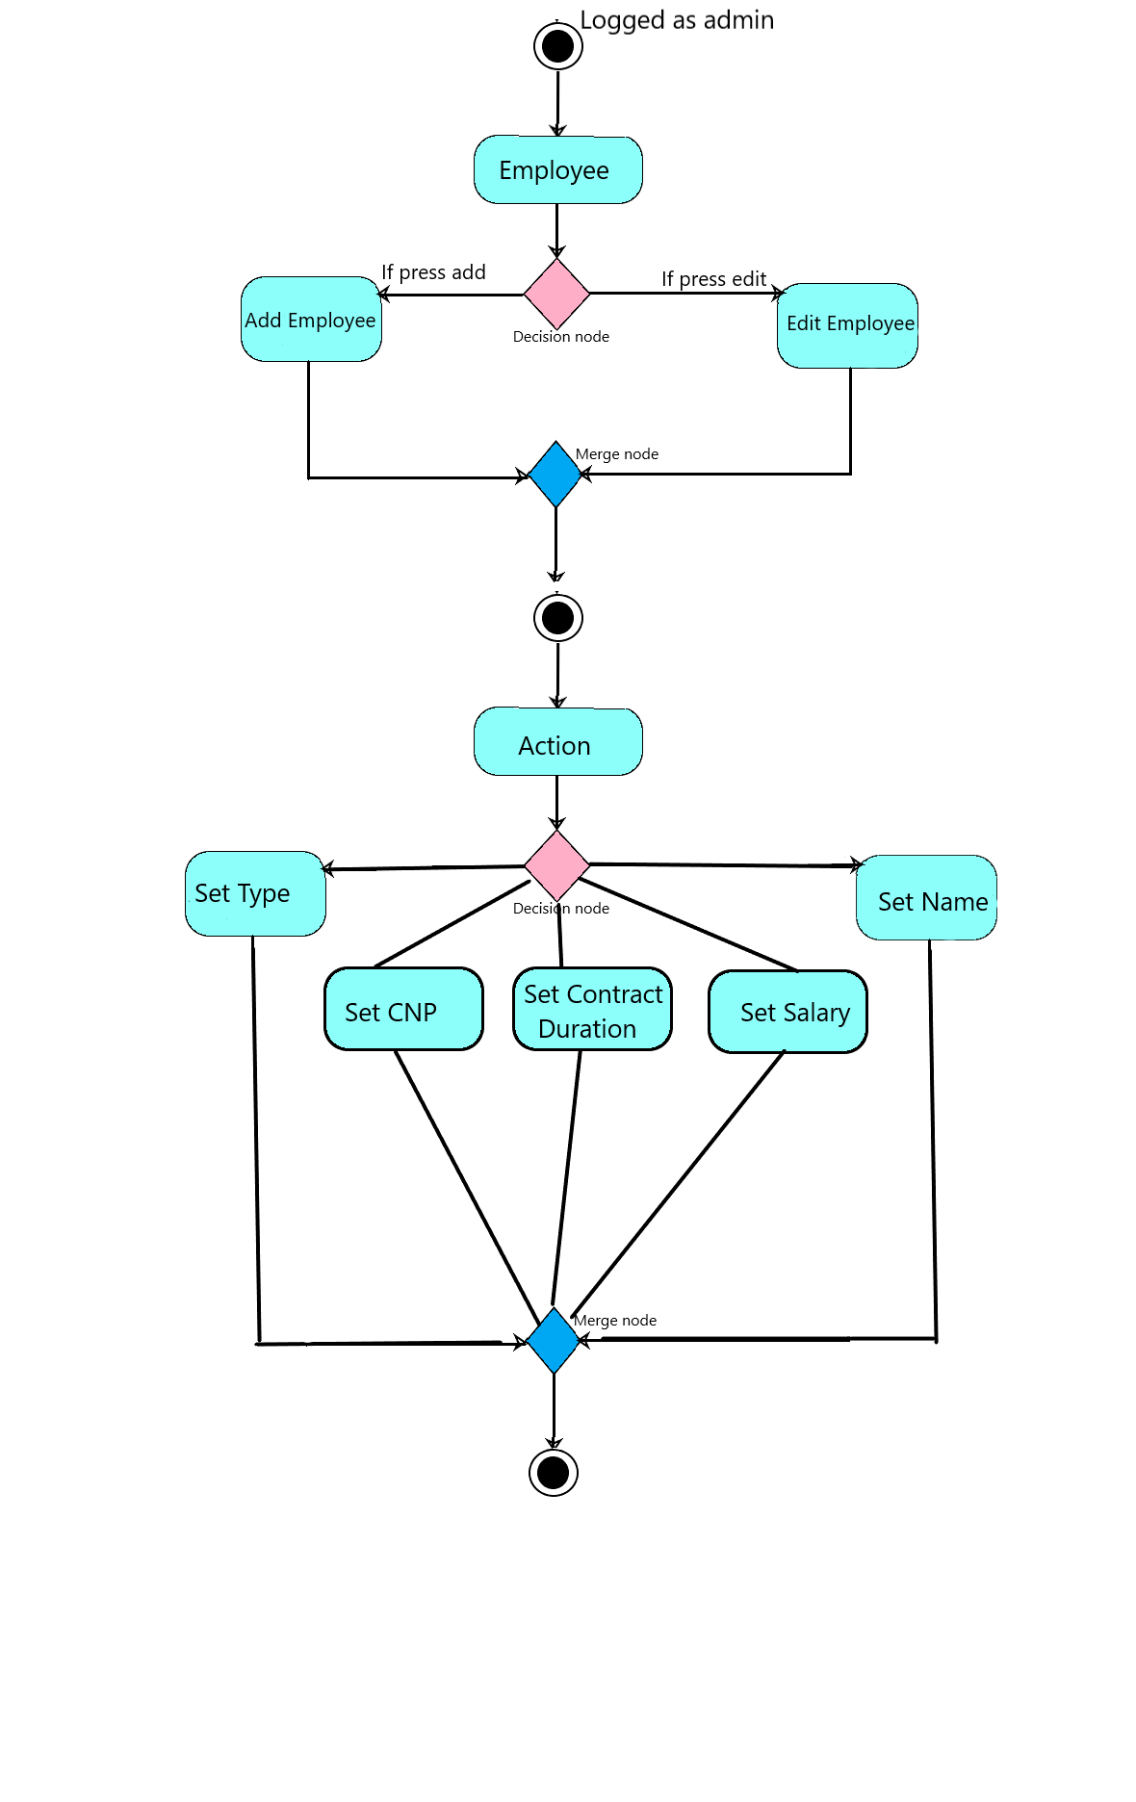

Employee diagram:

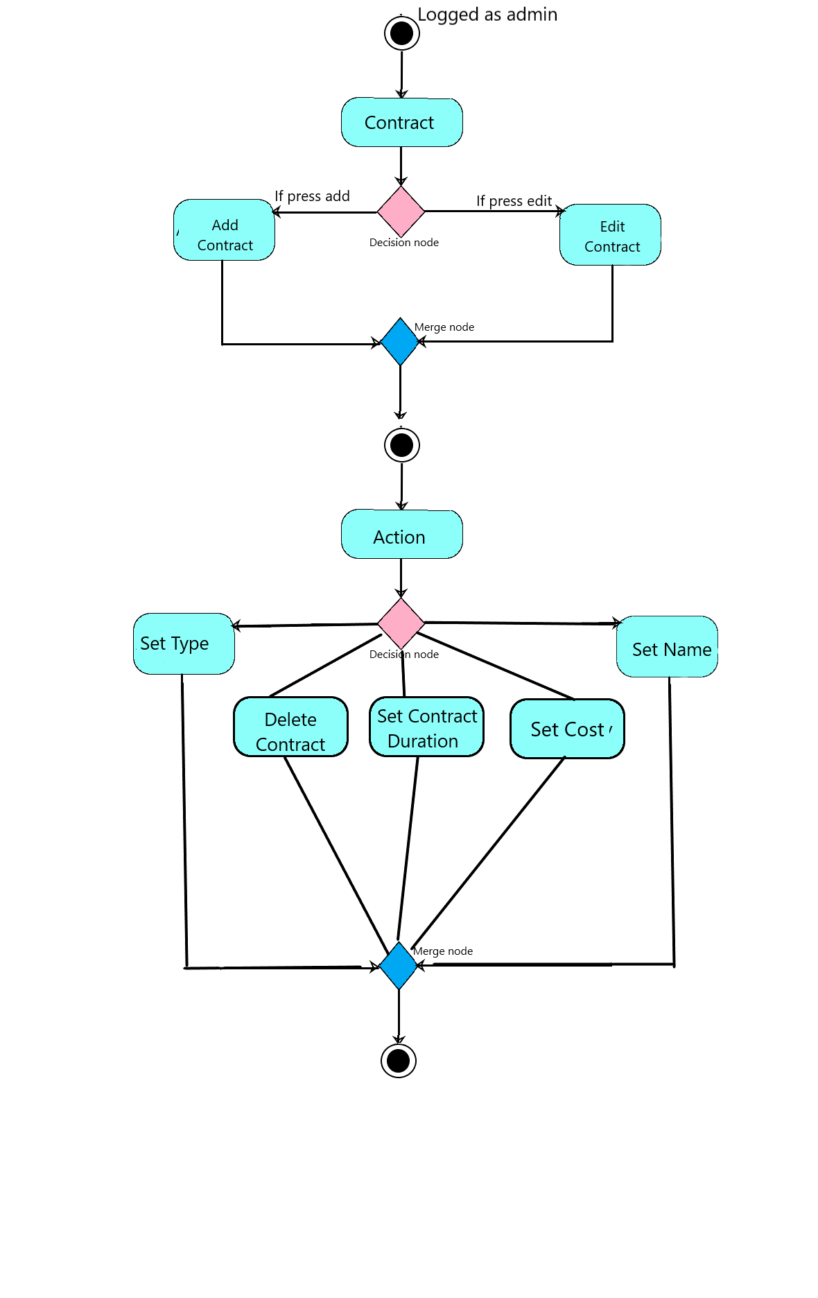

Contract diagram:

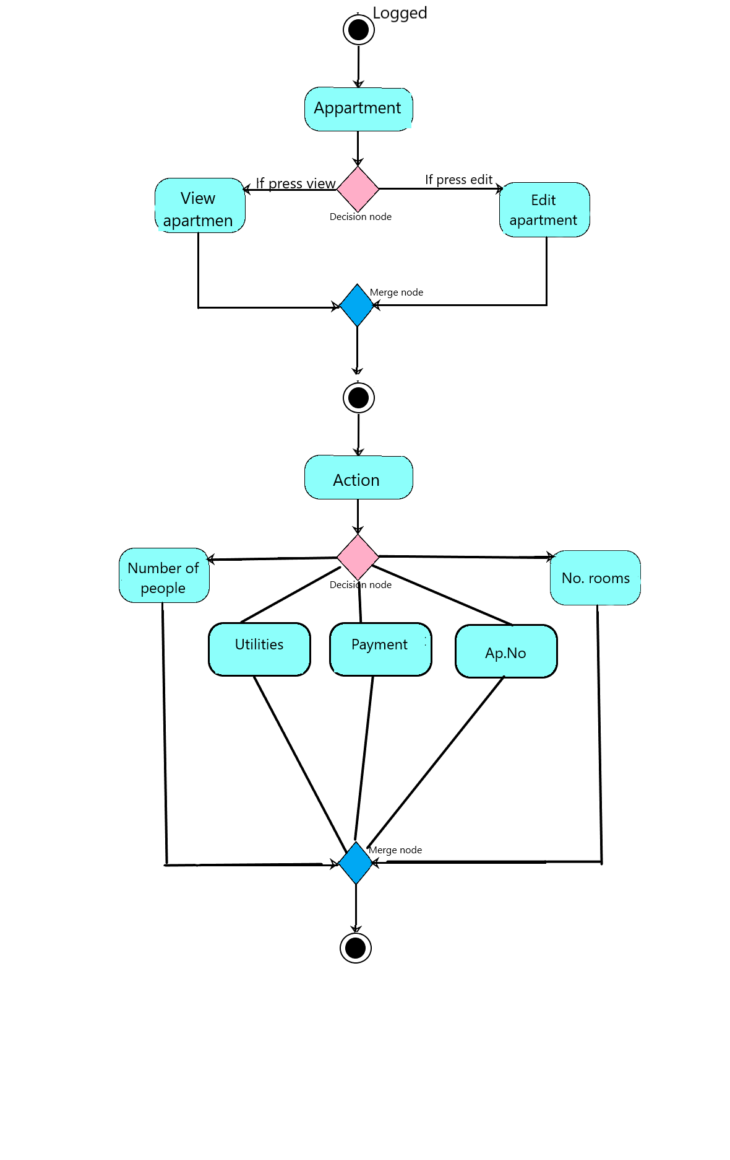

Appartment diagram:

Admin diagram:

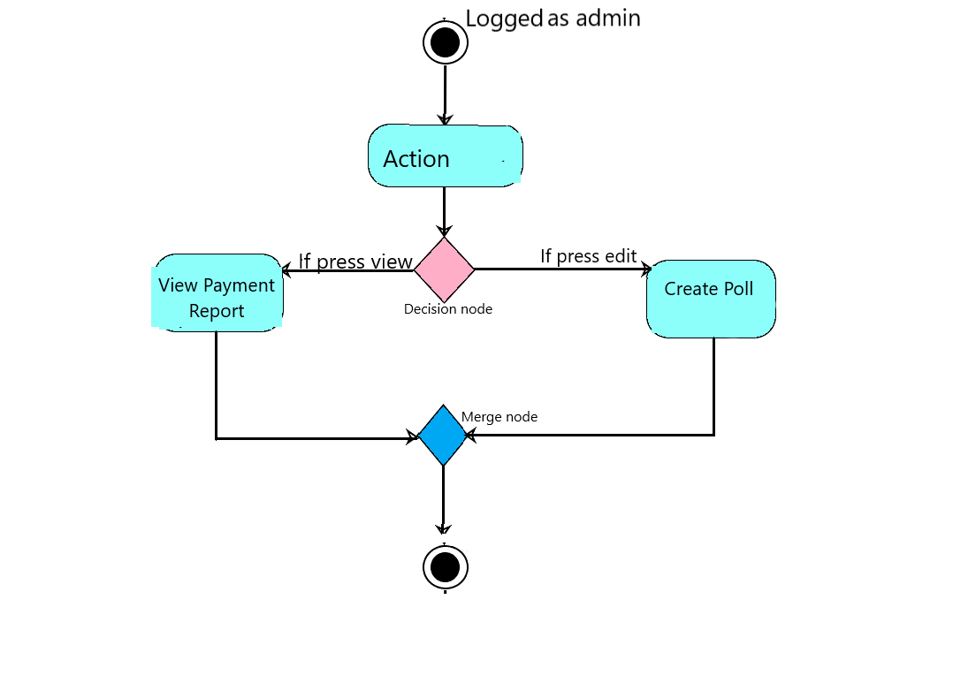

1. **Class Diagrams:**

|  |  |  |  |  |  |  |  |  |
| --- | --- | --- | --- | --- | --- | --- | --- | --- |
| Employee | Contract | Apartment | User | PaymentReport | Contact | Association | Address | Pool |
| E_Id | Con_Id | Ap_Id | U_Id | PR_id | Cnt_Id | As_id | Ad_id | P_Id |
| First_name | Type | Ap_number | First_name | employeessalary | First_name | Name | address1 | Pool_creator |
| Last_name | Suplier_name | Tenant_name | Last_name | contractscost | Last_name | Address | city | Subject |
| Type | Duration | No._people | Email | repairingfund | Email | Users | state | Context |
| CNP | Cost | No._rooms | Username | total pay apps curent mounth | Subject | Contracts |  | Options |
| Age |  | Cold_water | Password | total pay apps debt | Context | Employees |  |  |
| Contract_duration |  | hot water | Hot_water | Phonenumber |  | Apartments |  |  |
| Salary |  | Electricity | Type | expense |  | Payment_report |  |  |
|  |  | Trash |  | income |  |  |  |  |
|  |  | Extrapayments |  | profit |  |  |  |  |

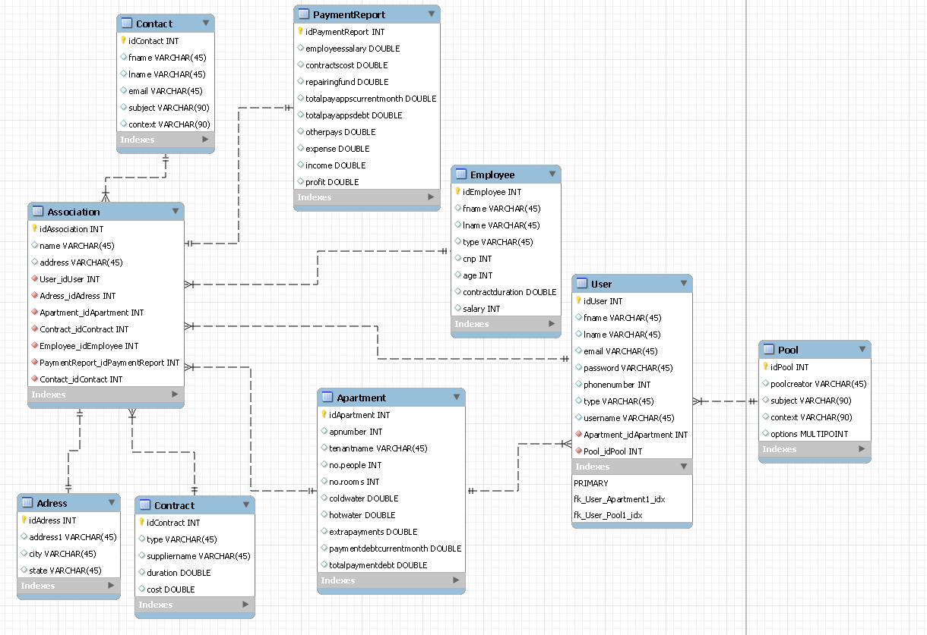**5. Relational Model Database:**